6A^{th} Grade: Unit 8, Lesson 1

- What is the value of the expression $36×\frac{1}{8}$?

$$4\frac{1}{2}$$

- What is the total number of unit cubes packed into the rectangular prism shown?
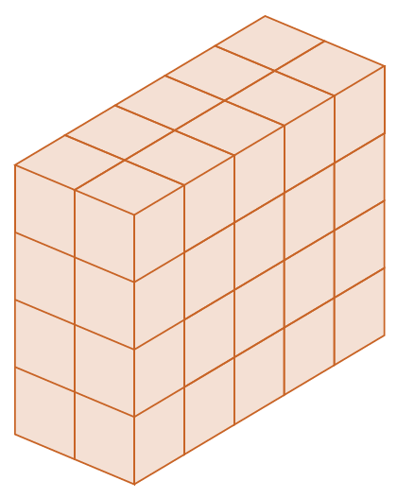
$$40$$

- What is the product of $\left(\frac{3}{4}\right)\left(\frac{3}{4}\right)\left(\frac{3}{4}\right)$?

$$\frac{27}{64}$$

